A Project Report
on
Event Finder
Submitted in partial fulfillment of the requirement of
Project – IV (BIT306CO)
BACHELOR IN INFORMATION TECHNOLOGY
Submitted to

Purbanchal University
Biratnagar, Nepal

Submitted by
Alisha Shahi (3505)
Bhavishek Lama (3505)
Riya Phuyal (350569)

KANTIPUR CITY COLLEGE
Putalisadak, Kathmandu
May,2026
A Project Report

on

Event Finder
Submitted in partial fulfillment of the requirement of
Project – IV (BIT106CO)

BACHELOR IN INFORMATION TECHNOLOGY

Submitted to

Purbanchal University
Biratnagar, Nepal

Submitted by
Alisha Shahi (350543)
Bhavishek Lama (350547)
Riya Phuyal (350569)

Project Supervisor
Bimochan Khadka
Maryada Karki
KANTIPUR CITY COLLEGE
Putalisadak, Kathmandu
May,2026

Abstract
This project presents a web-based Event Finder System developed using PHP for the backend and HTML5 and CSS3 for the frontend, with MySQL as the database management system. The system is designed to efficiently manage college or organizational events while also integrating a Lost and Found management feature for students. It provides role-based access for Admin and Student users. Admins can create, organize, and manage events, monitor student registrations, and oversee lost and found reports. Students can browse available events, pre-register online, receive timely notifications, and participate conveniently. Additionally, users can report lost items, post found items, match records, and track item status through the integrated Lost and Found module. The system stores all event and item-related data in a centralized database and delivers it through a user-friendly interface. This project improves communication, event participation, and item recovery processes while ensuring transparency, efficiency, and convenience, offering a reliable and cost-effective digital solution for event and student service management.

Acknowledgement
We would like to express our heartfelt gratitude to everyone who has supported and encouraged us throughout the completion of this project.
First and foremost, our sincere thanks go to Purbanchal University for introducing such a practical and insightful course, which has provided us the platform to explore and enhance our technical and academic capabilities.
We are deeply grateful to the entire team of Kantipur City College (KCC) for providing us with this valuable opportunity. We would especially like to extend our appreciation to the Principal of KCC, whose support and leadership have been instrumental in fostering an environment of learning and growth.
A special note of thanks goes to our respected supervisor, Bimochan Khadka and Maryada Karki whose consistent encouragement, guidance, and rich knowledge helped us throughout the course of this project. Their mentorship has truly been invaluable, and we could not have asked for better mentor.
We also acknowledge the contributions of each team member and our classmates, who shared suggestions, advice, and experiences that greatly enriched the project.
Finally, we extend our warmest thanks to our friends and colleagues who supported us both directly and indirectly. Your encouragement and help made this journey smoother and more meaningful.

Declaration
We declare that this project report titled “Event Finder” submitted in partial fulfillment of the Bachelor of Information Technology is a record of original work carried out by us under the supervision of Bimochan Khadka and Maryada Karki and has not formed the basis for the award of any other degree or Diploma, in this or any other institution or University. In keeping with the ethical practice of reporting scientific information, due acknowledgments have been made wherever the findings of others have been cited.

Alisha Shahi (350543)
Bhavishek Lama (350547)
Riya Phuyal (350569)

Supervisor’s Approval
This is to certify that the project entitled “Event Finder” undertaken and demonstrated by Alisha Shahi, Bhavishek Lama and Riya Phuyal has been successfully completed under my supervision as a partial fulfillment of the requirements of the degree of BIT V semester under Purbanchal University. I, henceforth, approve this project to be awarded the certificate by the concerned authority. During supervision, I found students hardworking, skilled and ready to undertake any professional work related to this field in future.

_____________
Bimochan Khadka
Project Supervisor
Department of IT

_____________
Maryada Karki
Project Supervisor
Department of IT

Certificate from Department
Following the Supervisor's Approval and Examiners' Acceptance, the project entitled “Multiplayer Dungeon Quest” submitted by Bhavishek Lama, Ravi Hathi and Hulas Chandra Chaudhari as a partial fulfillment of the requirements for the degree of BIT 4th under Purbanchal University, has been officially awarded by this certificate. I wish the students all the best for their future endeavors.

______________
Saroj Pandey
HoD
Department of IT
Kantipur City College

______________
Rubim Shrestha
Project Manager
Department of IT
Kantipur City College

Table of Contents
Abstract v
Acknowledgement vii
Declaration viii
Supervisor’s Approval ix
Certificate from Department x
Chapter 1: Introduction 1
1.1 Overview 1
1.1 Problem Statement 2
1.3 Objectives 2
1.4 Features 3
1.5 Significance 3
1.6 Scope and Limitations 4
1.7 Documentation Organization 5
Chapter 2: Literature Review 6
2.1 Background 6
2.1.1 Planning Pod 6
2.1.2 Coursedog 6
2.1.3 Accelevents 7
2.1.4 Eventbrite 7
2.2 Summary of Literature Review 8
Chapter 3: Methodology 9
3.1: Software Development Life Cycle 9
3.1.1: Selected Model 9
3.2 Technologies and Tools used 10
3.2.1 Programming Language (PHP) 10
3.2.2 Database (MYSQL) 10
3.2.3 Software Used 10
3.2.4 Integrated Development Environment (IDE) 11
3.4 Roles and Responsibilities 11
Chapter 4: System Analysis 13
4.1 Requirement Analysis 13
4.1.1 Requirement Gathering 13
4.1.2 Functional Requirement 14
4.2 Feasibility Study 14
4.2.1 Technical Feasibility 14
4.2.2 Economics Feasibility Economic feasibility evaluates whether the cost of developing the system is justified by the benefits it will provide. For this project: 15
4.2.3 Schedule Feasibility 15
4.2.3.1 Gantt chart 16
Chapter 5: System Design and Implementation 16
5.1System Architecture of Dungeon Quest (Multiplayer 2D Game) 16
5.1.1 Presentation Layer (Frontend) 17
5.1.3 Data Layer (Database) 17
5.2 Diagrams 18
5.2.1 DFD Level 0 18
5.2.2 DFD Level 1 19
5.2.3 Use case Diagram 20
5.2.4 ER-Diagram 21
Chapter 6: Testing and Debugging 22
6.1 Tools used in Testing 22
6.2 Test case 22
Chapter 7: System Development and Implementation 26
7.1 Programming Platform 26
7.2 Operating Environment 26
Chapter 8: Conclusion 26
References 27

List of Figure
Figure 3.1: Waterfall model.. 9
Figure 4.1: Gantt chart 16
Figure 5.1 DFD level 0 17
Figure 5.2 DFD level 1 18
Figure 5.3: Use Case Diagram 19
Figure 5.4: ER-Diagram 20

List of Table

Table 2.1: Analysis of Literaature Review 6
Table 3.1: Role and Responsibilities 9
Table 4.1: Requirement Gathering 11
Table 4.2: Functional Requirement 12
Table 6.1: Tools used in Testing 20
Table 6.2: Test Case 20

Chapter 1: Introduction
An Event Finder System is a web-based application that helps to manage and organize events while also providing an efficient platform for handling lost and found items digitally. It is designed to simplify event planning, student participation, and item recovery by reducing manual processes and improving communication. In this project, we have developed an Event Finder System using PHP along with HTML5, CSS3, and MySQL, which allows administrators to create, manage, and control events, while students can browse, pre-register, and receive notifications for upcoming events. Additionally, the integrated Lost and Found system enables users to report, post, match, and track lost or found items through a secure and user-friendly web application.

1.1 Overview
Event management and student service coordination are important tasks in educational institutions and organizations, as they directly impact student participation, communication, and overall operational efficiency. In many institutions, event registration and lost-and-found processes are often handled manually or through separate basic systems, which can lead to confusion, poor coordination, delayed updates, and data mismanagement. The lack of a centralized platform makes it difficult for administrators and students to efficiently manage events, registrations, and item recovery in real time.
To address these issues, this project focuses on designing a web-based Event Finder System using PHP along with HTML5, CSS3, and MySQL. The system is intended to securely manage event creation, planning, registration, and notifications through a centralized web application. It allows administrators to organize and control events, while students can browse events, pre-register, and receive updates conveniently. Additionally, the integrated Lost and Found system enables users to report, post, match, and track lost or found items, improving communication, accessibility, transparency, and efficiency in both event management and student support services.

1.1 Problem Statement
Manual and traditional methods of managing events, student registrations, and lost-and-found services are often inefficient and create several challenges in educational institutions and organizations, especially when handling large numbers of participants and records:
1. Time-Consuming Manual Processes: Traditional event planning, registration, and lost-and-found management often rely on paperwork or scattered communication methods, which consume significant time and increase administrative workload.
2. Higher Chance of Errors: Manual data entry for event registrations, notifications, or lost-and-found reports can lead to mistakes, resulting in inaccurate information, missed events, or unmatched items.
3. Lack of Centralized Data Management: Event details, participant records, and lost-and-found information are often stored in separate files or systems, making it difficult to manage, retrieve, and update data efficiently.
4. Limited Accessibility and Communication: Students may face difficulties accessing event information, registering on time, or tracking lost and found items due to delayed announcements or lack of a unified platform.

1.3 Objectives
The objective of the project is:
- To develop a web-based Event Finder System using PHP, HTML5, CSS3, and MySQL
- To efficiently manages event planning, student registrations, and lost-and-found services while automating event organization, registration processes, item reporting, and tracking

1.4 Features
Some of the features of the following project are:
- Secure Login: Users must enter valid credentials to access the system, ensuring data security and authorized usage.
- Role-Based Access: The system differentiates between Admin and Student roles, providing appropriate menus, permissions, and functionalities.
- Admin Functions: Admin can create, organize, update, and manage events, control student registrations, send notifications, and oversee lost-and-found reports.
- Student Functions: Students can browse available events, pre-register for events, receive timely notifications, and participate easily through the system.
- Lost and Found Management: Users can report lost items, post found items, search matching records, and track item status efficiently.
- Event Registration Control: Admin can monitor and manage participant registrations, ensuring organized event planning and execution.
- User-Friendly Web Interface: An intuitive and responsive interface developed using HTML5 and CSS3 ensures smooth user interaction.
- Real Time Notification: Students receive timely updates about upcoming events, registration status, and relevant announcements.

1.5 Significance
The Event Finder System plays a crucial role in modernizing event management and student service coordination by automating event planning, registration, notifications, and lost-and-found processes. By reducing manual paperwork and traditional communication barriers, the system ensures faster, more accurate, and organized management of events and student-related services. It provides timely access to event information, registration updates, and lost-and-found tracking for students and administrators, improving communication, transparency, and operational efficiency. This project highlights the importance of web-based applications in educational and organizational management by offering a cost-effective, scalable, and reliable solution for efficiently handling events, enhancing student participation, and improving support services.

1.6 Scope and Limitations
The scope of the Event Finder System is to design and implement a web-based solution for efficient management of events, student registrations, and lost-and-found services. Using PHP, HTML5, CSS3, and MySQL, the system allows administrators and students to securely access and manage event-related activities and item tracking through a centralized web application. Users can perform tasks such as creating and managing events, registering for events, reporting lost or found items, and tracking their status through a unified dashboard. The system aims to reduce manual workload, minimize communication gaps, improve transparency, and provide real-time access to event information and lost-and-found records from any location.
While developing the project, some advanced features were considered but could not be implemented due to time and resource constraints. These include:
- The system does not include a mobile application version, as it is currently designed only as a web-based platform.
- Advanced analytics or reporting features for event participation trends and lost-and-found statistics are not implemented.

1.7 Documentation Organization
This documentation provides a complete overview of the Event Finder System. Chapter 1 introduces the background, objectives, features, scope, and overall significance of the project. Further chapters describe the system design, detailed operation of event management and student registration, as well as the functionality of the lost-and-found module. It also includes the database structure, system workflow, and implementation details using PHP, HTML5, CSS3, and MySQL. The report highlights how the system improves upon traditional event handling methods and explains the centralized database approach and web-based communication process between users and the system.

Chapter 2: Literature Review

2.1 Background
Managing events, student participation, and lost-and-found services has become an important focus in educational institutions due to the need for better coordination, communication, and accessibility. Over time, different web-based platforms have been developed to simplify event handling and related services. This review examines existing solutions, highlighting their advantages and limitations, and shows how our system addresses the gaps present in current approaches.

2.1.1 Planning Pod
Planning Pod is an all-in-one event and venue management software used for organizing conferences, banquets, and events with tools for scheduling, budgeting, registration, and task management.
Pros:
- Easy to use and supports multiple event management features.
- Efficient for handling multiple events at once.
- Helps save time and improves organization.
Cons:
- More focused on venues than academic or campus events.
- Paid software, not suitable for small institutions.
- Can feel complex for basic event handling needs.

2.1.2 Coursedog
Coursedog is designed for higher education institutions to manage academic scheduling, campus events, and classroom bookings efficiently.
Pros:
- Ideal for universities and colleges.
- Reduces scheduling conflicts and improve coordination.
Cons:
- Complex setup for small institutions.
- Requires training and configuration.

2.1.3 Accelevents
Accelevents is a platform that supports in-person, virtual, and hybrid events with features like registration, ticketing, check-in, and event analytics.
Pros:
- User-friendly interface and strong support system.
- Works for different types of events (online/offline/hybrid).
- Advanced features like check-in and branding tools.
Cons:
- Expensive for frequent or large-scale use.
- Some features require additional setup.
- Not specifically designed for campus-only environments.

2.1.4 Eventbrite
Eventbrite is a popular event management platform used for creating, promoting, and managing events with ticketing and registration features.
Pros:
- Very easy to create and manage events.
- Strong event promotion and visibility.
- Trusted and widely used platform.
Cons:
- High service fees for paid events.
- Limited customization for institutional needs.
- Not fully focused on academic or campus-based systems.

2.2 Summary of Literature Review
Existing event management platforms provide useful features such as registration, scheduling, and promotion. However, most of them are either too complex, too expensive, or not specifically designed for educational institutions with integrated services like lost-and-found management. The proposed Event Finder System using PHP, HTML5, CSS3, and MySQL provides a centralized, simple, and cost-effective solution tailored for campus environments, combining event management, student registration, and lost-and-found services in one platform.

Chapter 3: Methodology

3.1: Software Development Life Cycle
By following an SDLC model, the development process can be broken down into manageable phases, allowing for better planning, tracking progress, and ensuring quality control. It also helps in identifying potential risks and errors at an early stage and addressing them effectively, which is essential when dealing with sensitive data such as user information and event data.
Additionally, using an SDLC model ensures that the final product meets the needs and expectations of all parties involved. Overall, incorporating an SDLC model in the development of event finder helps streamline the process, minimize errors, and deliver a reliable and efficient software solution.

3.1.1: Selected Model
For this project, an Iterative (Incremental) SDLC model was selected. This model combines the structured nature of traditional SDLC with the flexibility of iterative development. It is particularly suitable for small-scale, personal projects with limited timelines and evolving requirements.
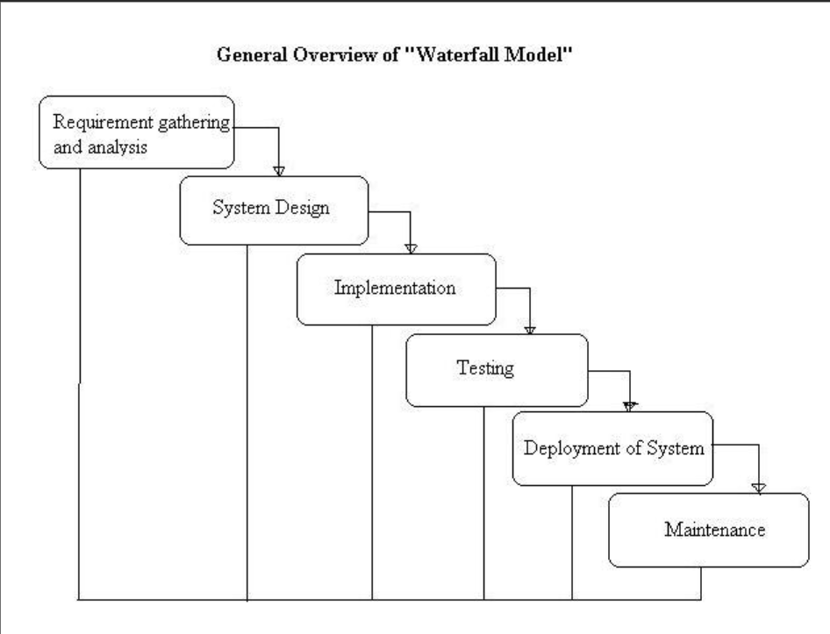
Figure 3.1: Waterfall model
The iterative model allows the system to be developed in small increments, where each iteration includes requirement analysis, design, implementation, and testing. Feedback from each iteration is used to improve the system in subsequent cycles.
Justification for Model Selection
- The project has a short development duration of few months.
- Requirements may evolve during development.
- Early delivery of a working prototype is beneficial.
- The model supports continuous testing and refinement.
- It reduces the risk of major failures at later stages.

3.2 Technologies and Tools used

3.2.1 Programming Language (PHP)
PHP is used as the primary server-side programming language for developing the backend of the system. It handles client requests, processes business logic, manages sessions, and interacts with the database. PHP is widely used for web development due to its simplicity, flexibility, and strong support for database integration, making it suitable for dynamic web applications like this project.

3.2.2 Database (MYSQL)
MySQL is used as the relational database management system for storing all system data, including user information, event details, registration records, notifications, and lost-and-found data. It provides efficient data storage, fast query processing, and supports structured relationships between tables. The database ensures data consistency, integrity, and secure access throughout the application.

3.2.3 Software Used
Apache is used as the web server to run the PHP-based application locally or on a hosting environment. HTML5 and CSS3 are used to design and structure the frontend of the system, providing a clean, responsive, and user-friendly interface for both administrators and students.

3.2.4 Integrated Development Environment (IDE)
Visual Studio Code (VS Code) is used as the main Integrated Development Environment for developing the Event Finder System. It provides features such as syntax highlighting, code auto-completion, debugging support, extensions for PHP development, and easy project management, which improves development efficiency and reduces coding errors.

3.4 Roles and Responsibilities
Table 3.1: Role and Responsibilities
Team Member | Task Performed
Alisha Shahi | - Coding  - Write PHP logic  - Database creation and connection  - Testing and Debugging  - Unit testing of each backend  - Check the connection of frontend with php  - Documentation
Bhavishek Lama | - Coding  - Write JavaScript logics  - Handle verifications and fetching data from backend for frontend  - Testing and Debugging  - Checking response and payload during operations  - Validation and other functions  - Documentation
Riya Phuyal | - Coding  - Create all HTML pages/forms  - Design the website using CSS  - Make pages responsive  - Testing and Debugging  - Test responsiveness of the page  - Testing the position of elements  - Documentation

Chapter 4: System Analysis

4.1 Requirement Analysis
Requirement’s analysis is the process of identifying and documenting the functional and non-functional needs of a system. It helps in understanding what the system should do and how it should perform.
In this project, requirements analysis is carried out to identify the needs of the Event Finder System developed using PHP with HTML5, CSS3, and MySQL. The analysis focuses on defining secure login mechanisms, role-based access for Admin and Student, efficient event creation and management, student registration for events, notification handling, and a lost-and-found reporting and tracking system.

4.1.1 Requirement Gathering
Requirement gathering is the process of collecting information about user needs and system expectations. In this project, requirements were gathered through discussions with other project members, supervisor and classmates as well as by observing the existing games.
Table 4. 1 Requirement Gathering
Requirement ID | Description
R1 | The system shall provide secure login and role-based access control for Admin and Student users.
R2 | The system shall allow the admin to create, manage, and organize events and control student registrations.
R3 | The system shall allow students to browse events, pre-register for events, and receive notifications.
R4 | The system shall allow users to report lost items, post found items, and search for matching records.
R5 | The system shall store and manage all event, registration, and lost-and-found data in a centralized MySQL database with a user-friendly web interface.

4.1.2 Functional Requirement
Table 4.2: Functional Requirement
Function ID | Description | Cross Reference with Requirement
F1 | User authentication and role-based access control for Admin and Student. | R1
F2 | Admin management of event creation, updates, deletion, and control of student registrations. | R2
F3 | Student browsing of events, pre-registration, and receiving notifications about events. | R3
F4 | Student reporting of lost items, posting found items, and searching for matching records in the system | R4
F5 | Centralized storage and retrieval of event, registration, and lost-and-found data through a web interface. | R5

4.2 Feasibility Study
Feasibility study is conducted to determine whether the proposed system is practical, cost-effective, and can be completed within the given time frame

4.2.1 Technical Feasibility
Technical feasibility assesses whether the technology, tools, and skills required to develop the system are available and suitable. For this project:
- PHP is used as the main backend programming language, which is widely supported for web development.
- HTML5 and CSS3 are used for creating a responsive and user-friendly web interface.
- MySQL provides centralized and efficient data storage for events and lost-and-found records.
- The development team has the necessary skills in web development, database management, and system design.

4.2.2 Economics Feasibility
Economic feasibility evaluates whether the cost of developing the system is justified by the benefits it will provide. For this project:
- Uses open-source technologies such as PHP, MySQL, HTML5, and CSS3, resulting in no licensing cost.
- Requires only basic hardware (computer system and local server setup like XAMPP).

4.2.3 Schedule Feasibility
Schedule feasibility examines whether the system can be completed within the allocated time frame. For this project:
- The project duration is approximately 5 months.
- Major phases include requirement analysis, system design, implementation, testing, and documentation.
- The small development team can efficiently manage tasks within the given schedule.

4.2.3.1 Gantt chart
Activities | Feb 2026 |  |  |  | March 2026 |  |  |  | April 2026 |  |  |  | May 2026
Week | 1 | 2 | 3 | 4 | 1 | 2 | 3 | 4 | 1 | 2 | 3 | 4 | 1 | 2 | 3 | 4
Project Start (Discussion)
Requirement Analysis
System Design
Frontend Development
Backend Development
Testing
Fixing Bugs
Documentation

Figure 4.1: Gantt chart

Chapter 5: System Design and Implementation

5.1System Architecture of Dungeon Quest (Multiplayer 2D Game)
The Event Finder is designed using a PHP-based backend with HTML5 and CSS3 for the frontend interface. The system follows a “three-tier architecture”, consisting of the Presentation Layer, Business Logic Layer, and Data Layer, ensuring modularity, scalability, and easy maintenance.

5.1.1 Presentation Layer (Frontend)
- Built using HTML5 and CSS3, this layer provides a user-friendly interface for all system roles: Admin and Student.
- It handles user input, displays web pages such as login forms, event listings, registration forms, and lost-and-found reporting pages.
- Ensures responsive and simple design for smooth user experience.
5.1.2 Business Logic Layer (Backend)
- Developed using PHP, this layer implements the core functionality of the system.
- It manages user authentication, role-based access control, event management, student registration processing, and lost-and-found operations.
- It acts as a bridge between the frontend and the database, processing all user requests.

5.1.3 Data Layer (Database)
- A centralized MySQL database is used to store all system data, including user information, event details, registration records, notifications, and lost-and-found data.
- It ensures data integrity, security, and efficient data retrieval for the application.

5.2 Diagrams

5.2.1 DFD Level 0
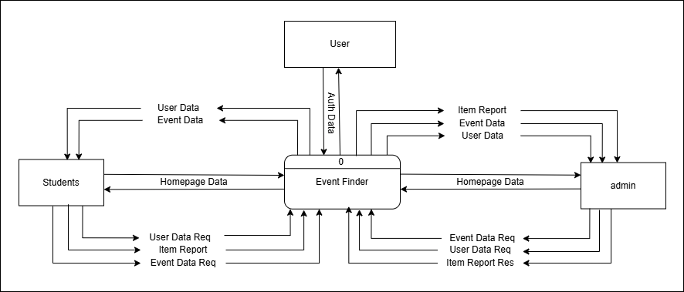Figure 5.1: DFD level 0

5.2.2 DFD Level 1
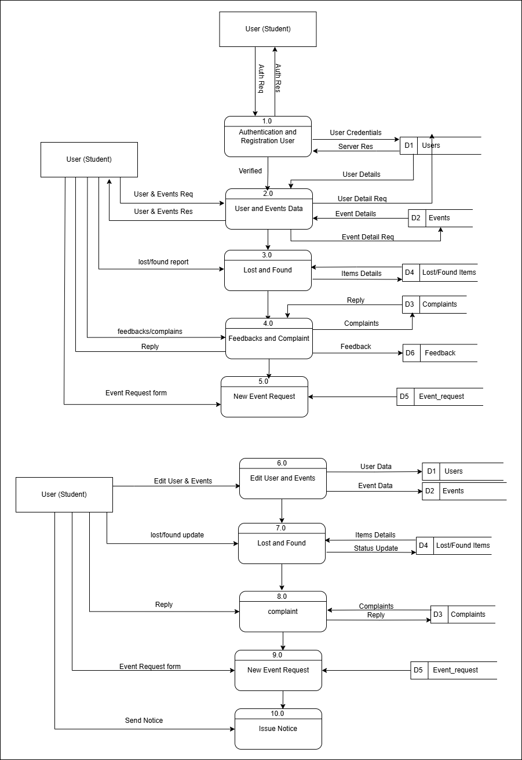
Figure 5.2: DFD level 1

5.2.3 Use case Diagram
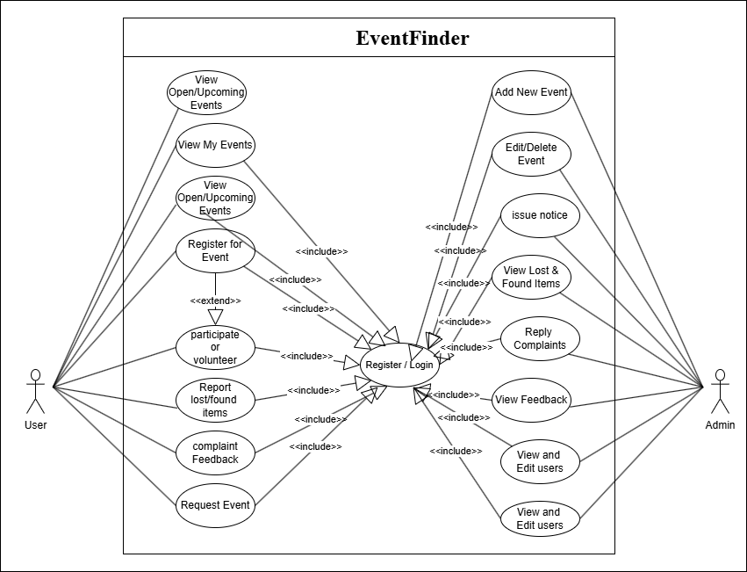
Figure 5.3: Use Case Diagram

5.2.4 ER-Diagram
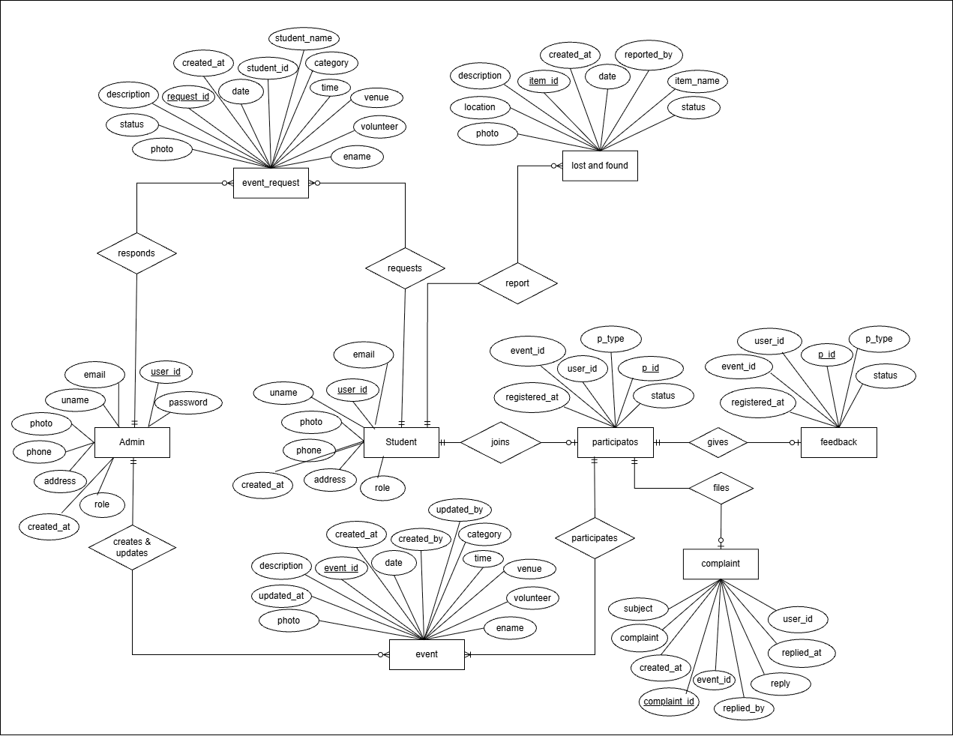
Figure 5.4: ER-Diagram

Chapter 6: Testing and Debugging
The system was tested to ensure all modules function correctly, including login, event management, student registration, and lost-and-found features. Testing was performed to identify and fix errors in code, database connectivity, and user interface issues. This ensures that the system works efficiently and meets user requirements.

6.1 Tools used in Testing
Table 7.1: Tools used in Testing
S.N. | Tools | Specification
1 | Hardware (Laptop) | Acer nitro V 16 AMD Ryzen 7 8845HS  Dell Inspiron Intel Core i5-1135G7  Lenovo IdeaPad Intel Core i5-8548U
2 | Testing software | Visual studio code  Xampp control pannel

6.2 Test case
Table 7.: Test Case
SN | Test objective | Expected Output | Result | Remarks
1 | Signup with digit in name | Button disable with feedback | Button disable | pass
2 | Signup with regular email | Button disable with feedback | Button disable | pass
3 | Signup with college email | Button enable with no feedback | Button enables | pass
4 | Signup with 11 digits in phone | Button disable with feedback | Button disable | pass
5 | Signup with 9 digits in phone | Button disable with feedback | Button enables | Fail  (no digit’s limit for 10 98)
6 | Signup with 9 digits in phone | Button disable with feedback | Button disable | pass
7 | Signup with 98/97 digit in phone | button enables and no feedback | Button enables | pass
8 | Signup with password without uppercase letter | Button disable with feedback | Button disable | pass
9 | Signup with password without symbol | Button disable with feedback | Button disable | pass
10 | Signup with password without digits | Button disable with feedback | Button disable | pass
11 | Signup with password without uppercase letter | Button disable with feedback | Button disable | pass
12 | Signup with password with only 7 letters | Button disable with feedback | Button disable | pass
13 | Signup with correct format password | Button enable with no feedback | Button enables | pass
14 | Signup with different confirm password | Button disable with feedback | Button disable | pass
15 | Signup with no photo | Button enable with no feedback | Button enables | pass
16 | Signup with photo | Button enable with no feedback | Button enables | pass
17 | login with wrong credentials | Feedback and clears input fields | Shows feedback and back to page | pass
18 | login with student credentials | Opens student homepage | Nothing happens | Fail, no database
19 | login with student credentials | Opens student homepage | Opens homepage | pass
20 | login with admin credentials | Opens admin homepage | Opens homepage | pass
21 | Homepage shows upcoming and recent events | Displays events in grid | Displays events | Pass  but can’t see event detail
22 | Show detail | Displays event detail | nothing only buttons | Fail, event id not sent
23 | Show detail by sending event id in URL (using GET) | Displays event detail | Displays event detail and buttons | pass
24 | User profile | Shows users photo and details | Shows default photo | fail
25 | User profile by fetching user data | Shows users photo and details | Shows users photo and details | pass
26 | Lists all the events participated by user | Shows event names and button | Shows list | pass
27 | List registered events by user | Shows event names and button | Shows list | pass
28 | Edit user | Displays user detail and input fields | Opens form with details | pass
29 | Edit user | Updates user data | Updates data in database | pass
30 | history | Lists user feedback, complaint and event request | Failed to display history | fail
31 | History after adding complaint, feedback and event requests | Lists user feedback, complaint and event request | Lists user history | pass
32 | Feedback and complaint | Displays event details with input field | Opens modal | pass
33 | Lost and found | Opens a reporting modal | Opens modal | Fail, data not sent to database
34 | Lost and found after fetching event id | Sends data to the database | Sends data | pass
35 | Cerate events | Opens event creation modal | Opens modal | pass
36 | Issue notices | Opens notice modal | Opens modal and sends mail to all users | Fail, doesn’t send mail

Chapter 7: System Development and Implementation

7.1 Programming Platform
- Main Language: PHP – used for backend functionality, processing logic, and handling server-side operations of the system.
- IDE / Software Used: Visual Studio Codes (VS Code) – for coding, debugging, and project management.
- Frontend Tools: HTML5 and CSS3 – for building a user-friendly and responsive and structured interface.
- Database Connectivity: MySQL – used to connect PHP with the MySQL database for data storage and retrieval.

7.2 Operating Environment
- Hardware: Intel Core i3+, 4 GB RAM, 500 MB storage
- Software: Any Modern Operating System (Windows/Linux/Mac), XAMPP/WAMP Server, MySQL, Chrome/Firefox browser
- Tested On: Windows 11 with XAMPP server, Visual Studio Code, MySQL database, and Google Chrome browser

Chapter 8: Conclusion
The Event Finder System provides a simple and efficient platform for managing events, student registrations, and lost-and-found services. It helps reduce manual work, improves communication, and ensures centralized data management. The system successfully meets its objectives and can be further enhanced in the future with additional features like mobile support and advanced notifications.

List of Abbreviations
CSS
ER
DFD
GUI
HTML
JSON
KCC
MYSQL
PHP
VS Code

References
PHP Manual. PHP: Hypertext Preprocessor Documentation. Available at: https://www.php.net/docs.php Accessed on 02/13/2026
MySQL Documentation. MySQL Reference Manual. Available at: https://dev.mysql.com/doc/ Accessed on 01/13/2026
MDN Web Docs. Web Development Basics (HTML, CSS, JavaScript). Available at: https://developer.mozilla.org/ Accessed on 02/13/2026
Planning Pod, Available at: https://planningpod.com/ Accessed on 02/13/2026
Coursedog, Available at: https://www.coursedog.com/ Accessed on 02/13/2026
Accelevents, Available at: https://www.accelevents.com/ Accessed on 02/13/2026
Eventbrite, Available at: https://www.eventbrite.com/ Accessed on 02/13/2026

